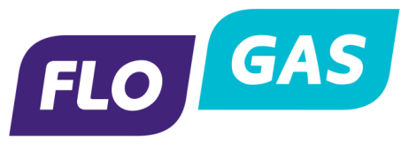

Flogas Natural Gas Limited
Deemed Gas Contract Scheme

Background
Flogas Natural Gas Ltd (“Flogas”) is required to make a scheme for determining the terms and conditions of its deemed contracts in accordance with condition 2 paragraph 1 of our Gas supply licence.
In accordance with Section 12 of the Energy Act Northern Ireland 2011 (the “Act”), Flogas is required to provide for deemed contracts for supply of gas where a gas supplier supplies gas to any premises otherwise than pursuant to a contract. As a result of this Flogas are required to make a scheme for determining Terms & Conditions which are to be incorporated into the deemed contracts.

Interpretation
This scheme will apply to any gas point registered to Flogas where a customer has decided not to agree a new supply contract, on the expiry of such a contract, or has never entered into a contract with Flogas.

Terms & Conditions
The terms and conditions that will apply to a Deemed Contract are the same as those applicable to a contract agreed between parties for the same product, except that the charges made to the customer will be based on standard tariff rates. The deemed rate applicable to a particular site, will include the applicable pass through charges associated with the supply of that site. The deemed contract and subsequent rates will be communicated by Flogas to the customer.

